Day 56

DIY

DIY Questions:

An employee is assigned to work on Jenkins where he has to download two plugins namely Warning next generation and Maven integration. He executes several Jenkins operations after creating a job with the Maven project. Assist the employee to perform the following task.

Tasks:

1. Start Jenkins Dashboard.

2. Download a plugin with the name Warnings next generation

3. Download plugin with name as Maven integration

4. Create a job –with project type as–Maven project

5. Add a java code repository in the Source code management

6. In the build step add the maven command to review the code for analysis i.e. pmd:pmd

7. Build the code and check if the pmd.xml file is generated or not in the workspace

8. Add post-build steps to convert the pmd.xml file into a code analysis report.

9. Build the job again and observe the code analysis warnings report.

Solutions:

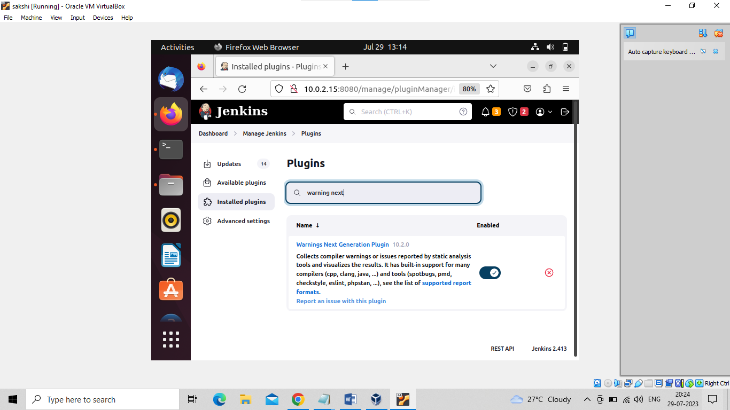

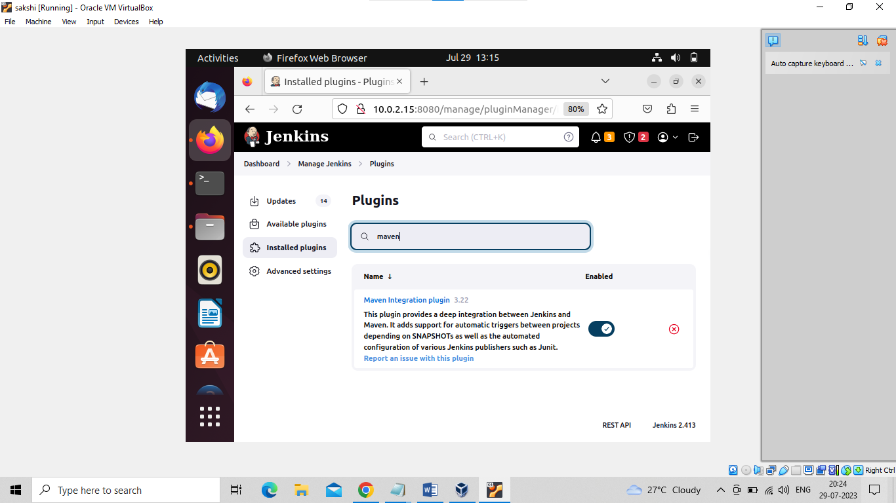

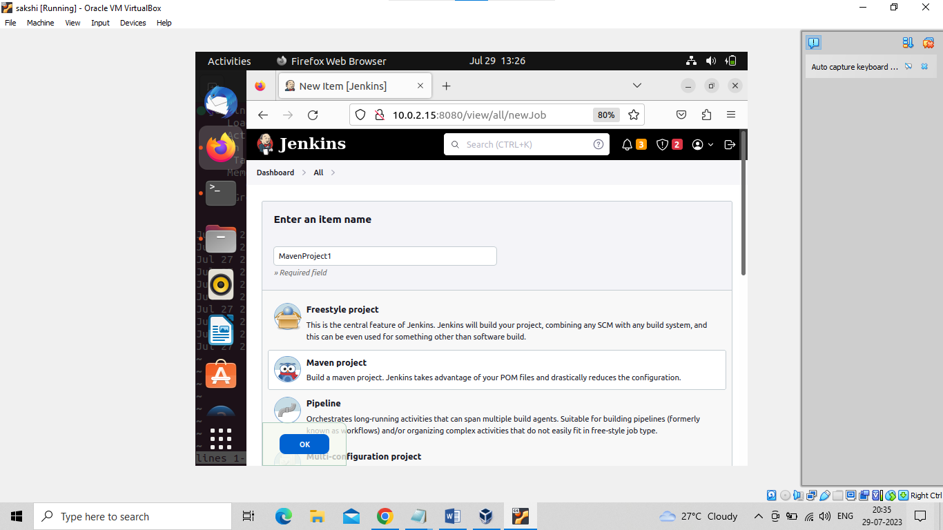

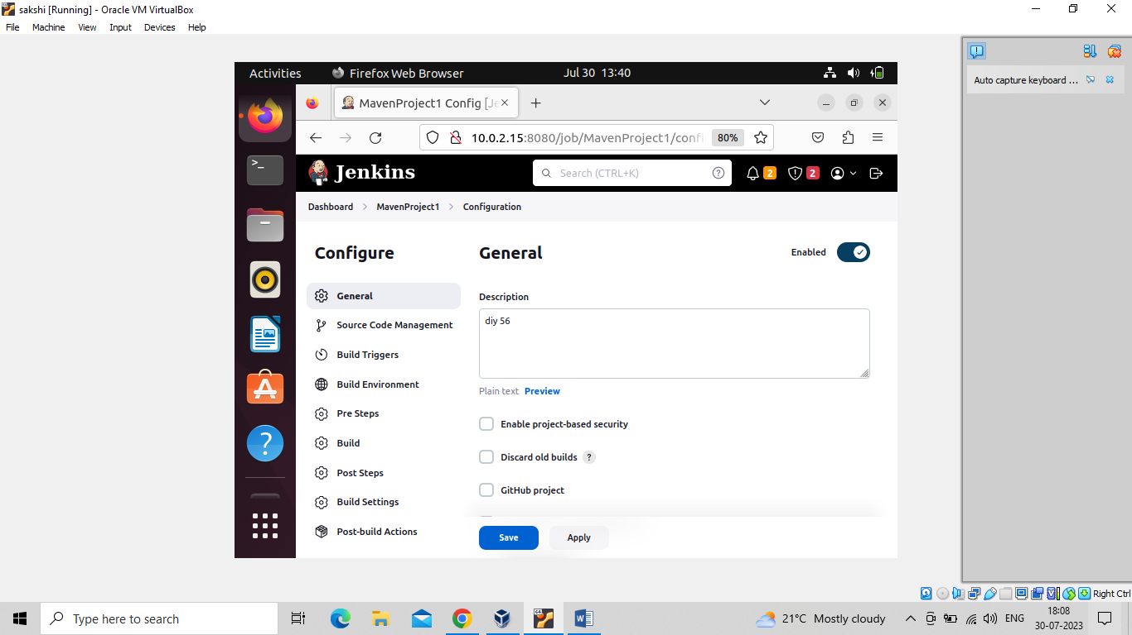

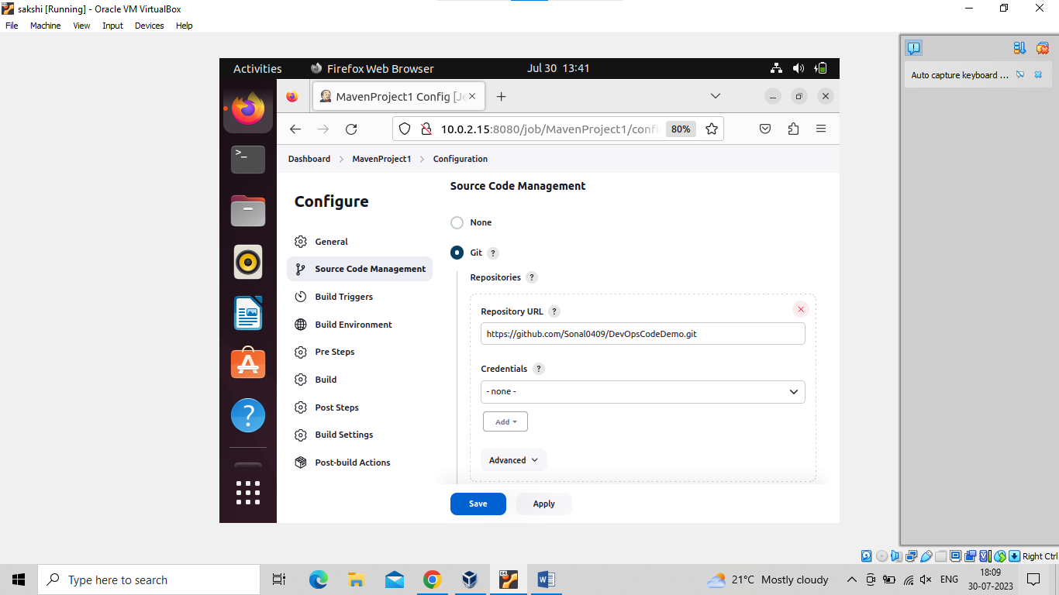

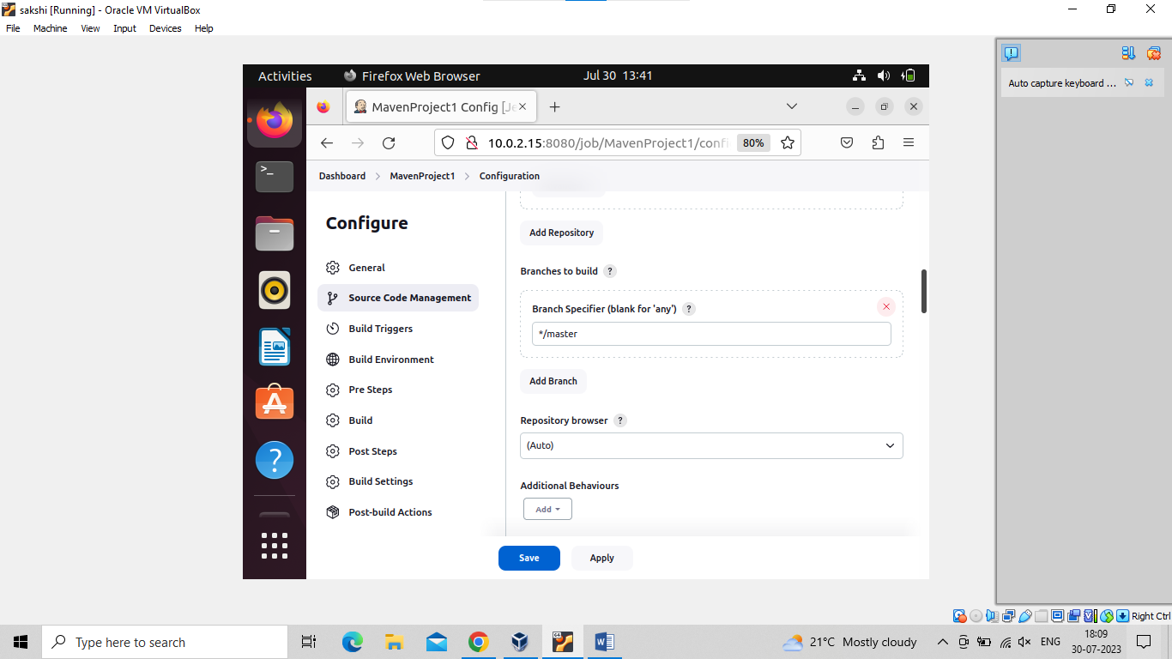

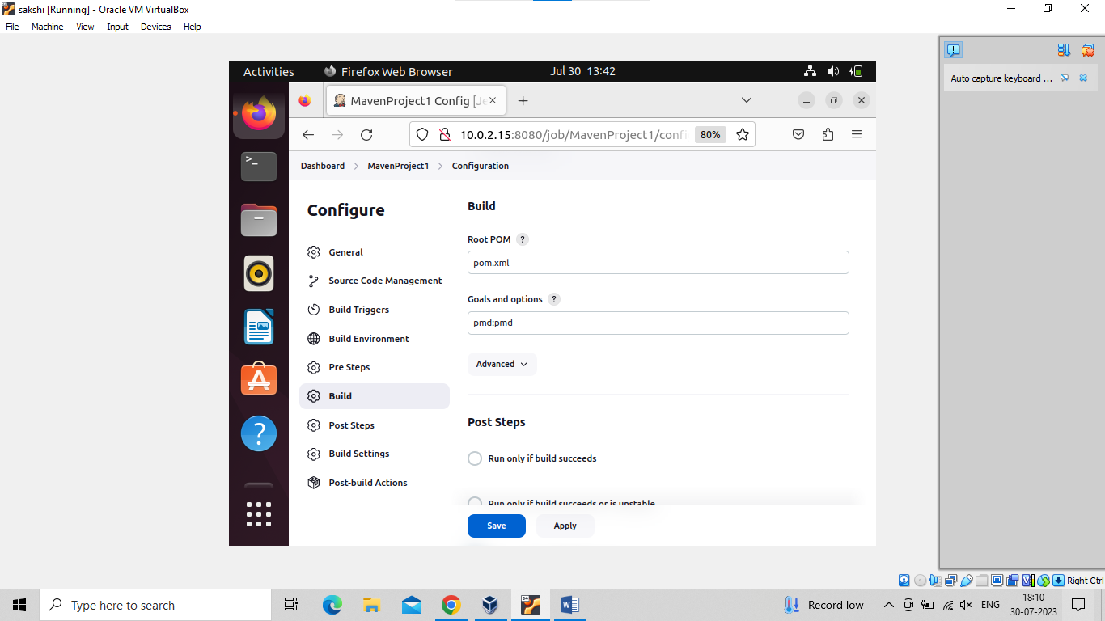

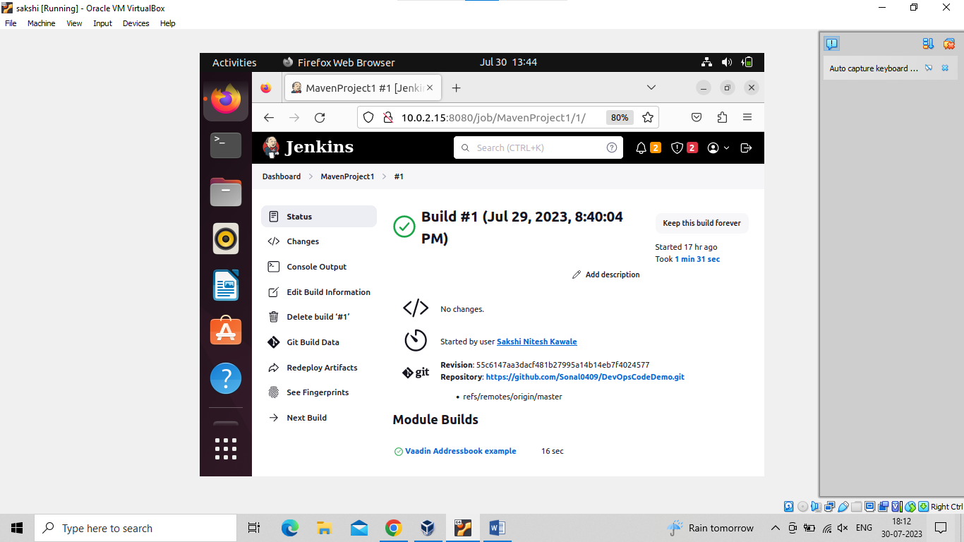

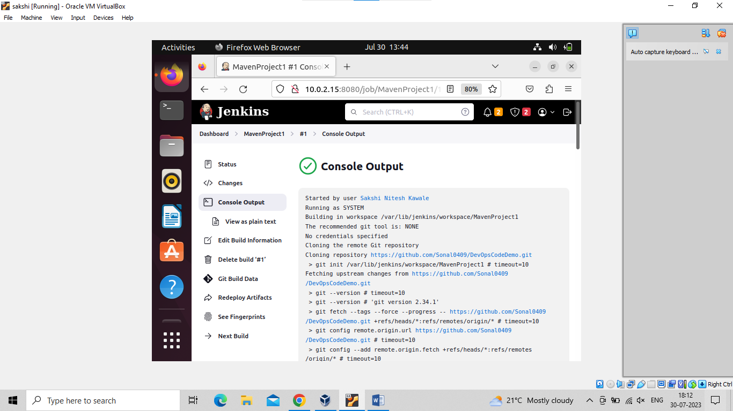

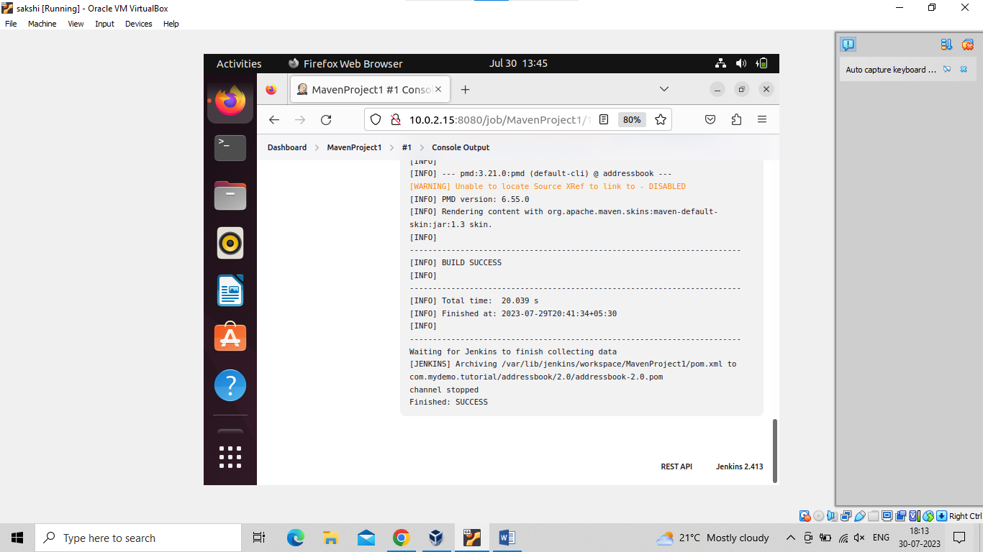

Now convert pmd.xml file into trend report

